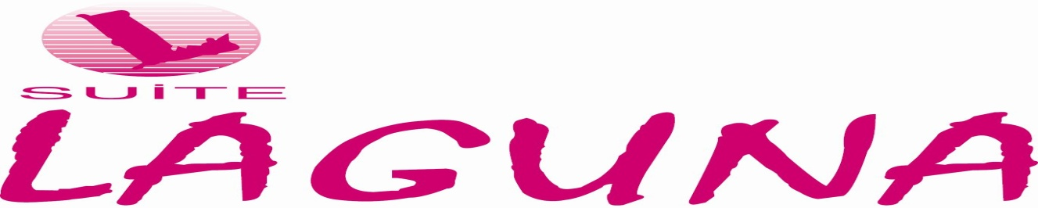

|  |
| --- |
| **GENERAL INFORMATION** |

*Category : Hotel*

*Total Area : 1500 square meters*

*Capacity : 91 Room*

*Concept : Room Only & Room Breakfast & Half board*

*Floors : 7 Floor*

*Credit Card : Visa-Mastercard-American Express*

*Address : Bahçelievler Mahallesi Teomanpaşa Caddesi No : 53 Merkez/ANTALYA/TÜRKİYE*

*Phone : +90-242-2433436 pbx*

*Fax : +90-242-2476818*

*Web :* [*www.suitelaguna.com*](http://www.suitelaguna.com)

*E-Posta :* [*info@suitelaguna.com*](mailto:info@suitelaguna.com)

*Rezervation :* [*reservation@suitelaguna.com*](mailto:reservation@suitelaguna.com)

|  |
| --- |
| **LOCATION** |

*Our faciliy,which was completely renovated in winter period of 2017-2018,is located in the city center in the most beautiful bay of the Mediterranean Sea .*

**Distance of Our Hotel to Some Centers**

*City Centers : 500 Mt*

*Airport (AYT) : 15 Km*

*Museum : 500 Mt*

*Antalya Expo Center : 15 Km*

**Nearest Tourist Centers Historical Places**

*Kemer : 45 Km Phaselis : 55 Km*

*Çamyuva : 52 Km Olympos : 75 Km*

*Tekirova : 60 Km Perge : 20 Km*

*Belek : 45 Km Aspendos : 50 Km*

Bahçelievler Mahallesi Teomanpaşa Caddesi No:53 Merkez/Antalya/Türkiye

<Tel:+90-242-2433436> Fax:+90-242-2476818

[www.suitelaguna.com](http://www.suitelaguna.com) info@suitelaguna.com

**Ski Resorts Golf Centers**

*Saklıkent : 40 Km Belek : 45 Km*

*Tahtalı : 60 Km*

**Dive Centers**

*The Nearest : 1 Km*

*Kemer : 45 Km*

**Transportation**

*Our hotel is located 100 meters from 100. Yıl Boulevard.There are local minibuses and buses on the street every minute.The are also taxis in front of the hotel 24/7 hours a day.*

|  |
| --- |
| **ROOMS** |

**Total Room Capacity: 91 Total Bed Capacity : 200**

**Superior Rooms:**

*Room Sizes :25 m2*

*Maksimum Capacity :2 Adults*

*In our rooms, which consist of 1 bedroom and 1 bathroom with a contemporary and peaceful decoration, shower cabin, adjustable hair dryer, adjustable split air conditioner for all seasons, direct dial telephone, free wireless high speed ADSL internet, LCD screen television with national and international channel options, Minibar, There are special in-room safes in which a laptop can be fitted (our guests can charge their laptops with a special socket placed inside the safe). Our safes can be coded with 4-6 special codes to be determined by our guests.* *There is a French balcony, make-up mirror, illuminated desk, chair, coffee table. Our rooms have a door with an electronic card and a second lock system inside, and the floor of the room is laminated parquet.*

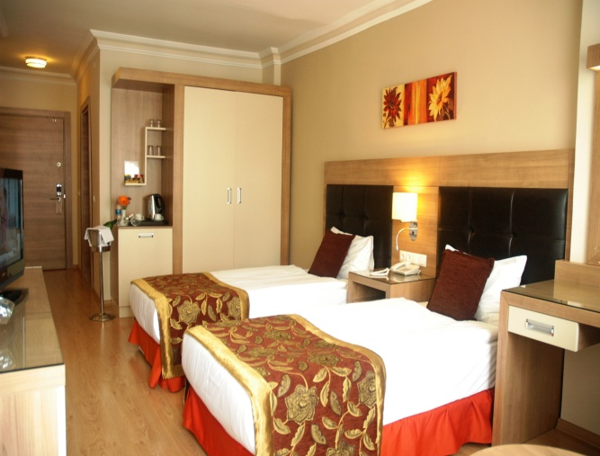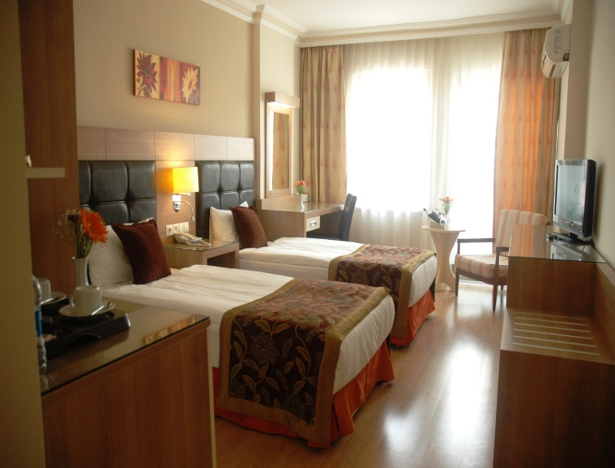

Bahçelievler Mahallesi Teomanpaşa Caddesi No:53 Merkez/Antalya/Türkiye

<Tel:+90-242-2433436> Fax:+90-242-2476818

[www.suitelaguna.com](http://www.suitelaguna.com) [info@suitelaguna.com](mailto:info@suitelaguna.com)

**Junior Suite Rooms:1+1 APART**

*Room Sizes :35m2*

*Maksimum Capacity : 2 Adults + 1 Child*

*In Junior Suite room, 1 bedroom and 1 living room, 1 bathroom, shower cabin, hair dryer, split air conditioner that can be adjusted according to all seasons, direct dial telephone, free wireless high speed ADSL internet, LCD screen television with national and international channel options, Minibar, Indoor There are special in-room safes that can fit laptops (our guests can charge their laptops with a special socket placed inside the safe).Our safes can be coded with 4-6 special codes to be determined by our guests. There is a direct dial telephone, a minibar, a make-up mirror and a sitting group. Our rooms have an electronic card door and a second lock system inside, and the floor of the room is laminated parquet. These rooms do not have a balcony.*

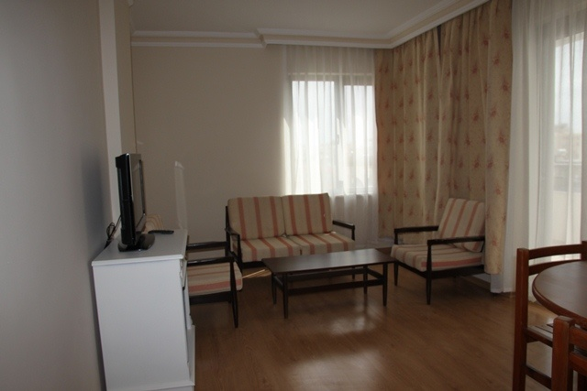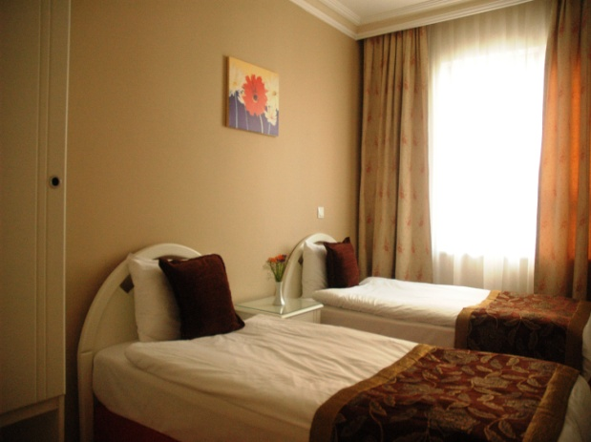

Bahçelievler Mahallesi Teomanpaşa Caddesi No:53 Merkez/Antalya/Türkiye

<Tel:+90-242-2433436> Fax:+90-242-2476818

[www.suitelaguna.com](http://www.suitelaguna.com) [info@suitelaguna.com](mailto:info@suitelaguna.com)

**Family Suite Rooms:2+1 APART**

*Room Sizes :55m2*

*Maksimum Capacity : 4 Adults*

*Family Suite room, 2 bedrooms, 1 living room, 1 bathroom, shower cabin, hair dryer, split air conditioner that can be adjusted according to all seasons, direct dial telephone, free wireless high speed ADSL internet, LCD TV with national and international channel options, Minibar, balcony, Indoor There are special in-room safes that can fit laptops (our guests can charge their laptops with a special socket placed inside the safe).* *Our safes can be coded with 4-6 special codes to be determined by our guests. There is a direct dial telephone, a minibar, a make-up mirror and a sitting group. Our rooms have an electronic card door and a second lock system inside, and the floor of the room is laminated parquet.*

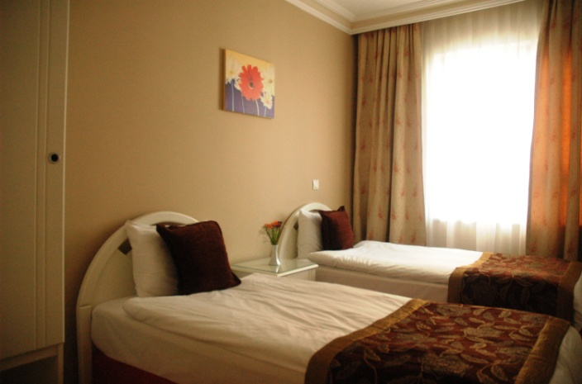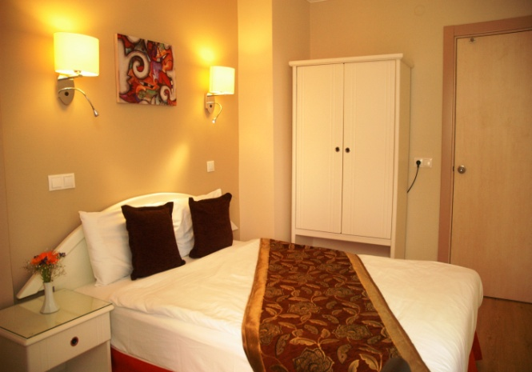

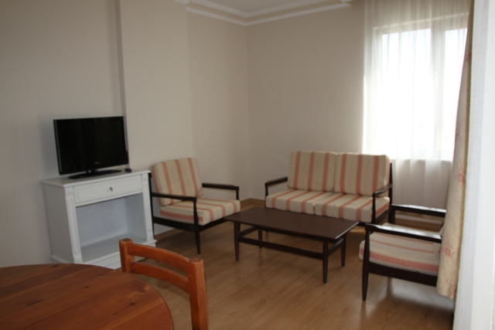

* Pets are not accepted in our hotel.

Bahçelievler Mahallesi Teomanpaşa Caddesi No:53 Merkez/Antalya/Türkiye

<Tel:+90-242-2433436> Fax:+90-242-2476818

[www.suitelaguna.com](http://www.suitelaguna.com) info@suitelaguna.com

OUR SERVICES

Hotel Facilities: • Reception Service: Our reception operates 24/7, ready to assist guests with any questions or requests.

• Free Wi-Fi: Complimentary high-speed Wi-Fi access is available throughout the hotel

.• Cleaning Service: Daily room cleaning and regular towel replacement are provided

• Parking: Free parking is available for guests arriving with their own vehicles.

• Beach Service: Our hotel provides complimentary shuttle service for guests to Konyaaltı

Beach three times a day from the hotel and twice from Konyaaltı Beach to the hotel.

FOOD & BEVERAGE

VENUES INDOOR AREA OUTDOOR AREA OPENING TIME CLOSING TIME

Breakfast 130 pax 100 pax 07:30 - 09:30 Main Restaurant

Dinner 130 pax 100 pax 19.00 – 21.00 Main Restaurant

*The opening and closing hours of the mentioned restaurants and bars may vary depending on the operation and seasonal conditions of the facility.

RESTAURANT

• Dress codes are enforced in our restaurants.

• Fresh orange juice and freshly squeezed fruit juices are available for an additional charge.

• Smoking is not allowed in all our indoor areas.

Bahçelievler Mahallesi Teomanpaşa Caddesi No:53 Merkez/Antalya/Türkiye

<Tel:+90-242-2433436> Fax:+90-242-2476818

[www.suitelaguna.com](http://www.suitelaguna.com) info@suitelaguna.com

Bahçelievler Mahallesi Teomanpaşa Caddesi No:53 Merkez/Antalya/Türkiye

<Tel:+90-242-2433436> Fax:+90-242-2476818

[www.suitelaguna.com](http://www.suitelaguna.com) [info@suitelaguna.com](mailto:info@suitelaguna.com)